# 19,78 m



## 1,63 m

**PV**



**PV**



**Solar**

**panels**

**1m**

**2 m**

**2 m**

# 10

**m**



DC DC DC

CA CA CA

**CA**

**=**

**~**

**=**

**~**

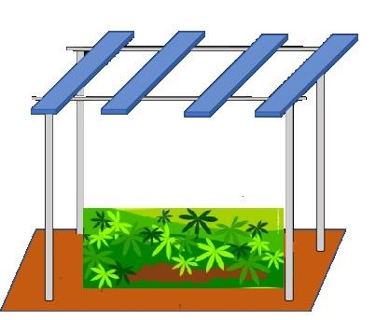

**AC common bus**

**Consumer load**

**Inverter**

**=**

**~**

**Meter**

**generation**

**Bidirectional**

**meter**

**Electric grid**

**Agrivoltaic**

**Baterry**

**Inverter**

**=**

**~**

**Controller**

**Optimization algorithm**



